**Analytics Tool - Adobe Experience/Launch**

A Project-II Report

Submitted in partial fulfillment of the requirement of the

Degree of

**BACHELOR OF TECHNOLOGY in COMPUTER SCIENCE & ENGINEERING**

BY

**Mohith H Pillai**

**EN19CS303032**

Under the Guidance of

**Gaurav Sharma Sir**



**Department of Computer Science & Engineering**

**Faculty of Engineering**

**MEDI-CAPS UNIVERSITY, INDORE- 453331**

**May 2023**

**Report Approval**

The project work **“Analytics Tool Adobe Experience/Launch”** is hereby approved as a creditable study of an engineering/computer application subject carried out and presented in a manner satisfactory to warrant its acceptance as prerequisite for the Degree for which it has been submitted.

It is to be understood that by this approval the undersigned do not endorse or approve any statement made, opinion expressed, or conclusion drawn there in; but approve the “Project Report” only for the purpose for which it has been submitted.

Internal Examiner

Name:

Designation

Affiliation

External Examiner

Name:

Designation

Affiliation

**Declaration**

I/We hereby declare that the project entitled **“Analytics Tool Adobe Experience/Launch”** submittedin partial fulfillment for the award of the degree of Bachelor of Technology/Master of Computer Applications in ‘CSE’ completed under the supervision of **Mr. Gaurav Sharma Sir, Project Coordinator,** Faculty of Engineering, Medi-Caps University Indore is an authentic work.

Further, I/we declare that the content of this Project work, in full or in parts, has neither been taken from any other source nor has it been submitted to any other Institute or University for the award of any degree or diploma.

**Signature and name of the student with date**

**Mohith H Pillai -EN19CS303032**

**Certificate**

I **Mr. Gaurav Sharma** certify that the project entitled **“Analytics Tool Adobe Experience/Launch”** submittedin partial fulfillment for the award of the degree of Bachelor of Technology/Master of Computer Applications by **Mohith H Pillai** istherecordcarried out by him/them under my/our guidance and that the work has not formed the basis of award of any other degree elsewhere.

________________________________

**Mr. Gaurav Sharma**

Computer Science Engineering

Medi-Caps University, Indore

________________________________

_____________________

Dr. Ratnesh Litoriya

Head of the Department

Computer Science & Engineering

Medi-Caps University, Indore

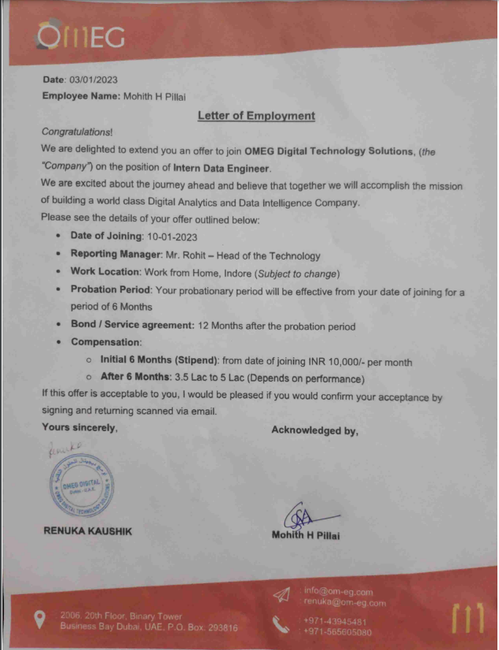

**Acknowledgements**

I would like to express my deepest gratitude to Honorable Chancellor, **Shri R C Mittal,** who has provided me with every facility to successfully carry out this project, and my profound indebtedness to **Prof. (Dr.) Dilip K. Patnaik,** Vice Chancellor, Medi-Caps University, whose unfailing support, and enthusiasm has always boosted up my morale. I also thank **Prof. (Dr.) Pramod S. Nair,** Dean, Faculty of Engineering, Medi-Caps University, for giving me a chance to work on this project. I would also like to thank my Head of the Department **Dr. Ratnesh Litoriya** for his continuous encouragement in the betterment of the project.

I express my heartfelt gratitude to my **External Guide, Mr. Rohit Neema,** Chief Technical Officer, Om-eg Digital technology Solutions,as well as to my Internal Guide, **Mr. Gaurav Sharma Sir**, Assistant Professor, Department of Computer Science and Engineering, MU, without whose continuous help and support, this project would never have reached to the completion.

It is their help and support, due to which we were able to complete the design and technical report.

Without their support, this report would not have been possible.

**Mohith H Pillai (EN19CS303032)**

B.Tech. IV Year

Department of Computer Science & Engineering

Faculty of Engineering

Medi-Caps University, Indore

**Abstract**

The purpose of this report is to provide an overview of Adobe Launch, a Data analytics tool used by organizations worldwide. The report covers the various features of Adobe, how it works, and its benefits.

Adobe Launch is a Data Analytics tool developed by Adobe Inc. It is designed to help teams plan, test, and manage projects efficiently. Adobe Launch is widely used by analyst teams, to create dashboards, test sites and apps data tracking.

One of the main features of Adobe Launch is that we can get a single view into all the data being collected on your web and mobile properties for better quality control and sharing. Adobe Launch allows analysts to create dashboards, test the data being tracked, and track issues through a user-friendly interface.

Another important feature of Adobe Launch is that Experience Platform Launch was built with an API-first design, which allows for scripting to automate technology deployments, publishing workflows, data collection and sharing and more. So, the time-consuming tasks of the past, like web tag management or mobile SDK configuration, take less time — giving you maximum control and automation.

Adobe Experience Platform Launch is here to make learning and implementing new technology straightforward. Experience Platform Launch was designed from the beginning to be easy to master and simple to understand, featuring a clean user interface that helps you to deploy technologies faster, so you can spend your time on other tasks.

**Table of Contents**

|  |  |  |
| --- | --- | --- |
|  |  | **Page No.** |
|  |  |  |
|  | Report Approval | ii |
|  | Declaration | iii |
|  | Certificate | iv |
|  | Acknowledgement | v |
|  | Abstract | vi |
|  | Table of Contents | vii |
|  | List of figures | viii |
|  | List of tables | ix |
|  | Abbreviations | x |
|  | Notations & Symbols | xi |
| Chapter 1 | Introduction |  |
|  | 1.1 Introduction | 1 |
|  | 1.2 Literature Review | 2 |
|  | 1.3 Objective | 3 |
|  | 1.4 Significance | 4 |
| Chapter 2 | Adobe Experience Platform |  |
|  | 2.1 Adobe Launch | 5 |
|  | 2.2 Adobe Launch Functionalities | 7 |
|  | 2.3 Creating Dashboard | 10 |
| Chapter 3 | System Workflow | 12 |
| Chapter 4 | Website (UI) | 12 |
| Chapter 5 | Result and Discussion | 14 |
| Chapter 6 | Conclusion | 15 |
| Chapter 7 | Further Improvements | 15 |
| Chapter 8 | References | 16 |
|  | Appendix | 16 |

**List of Figures**

|  |  |  |
| --- | --- | --- |
| **FIGURE NO.** | **NAME OF FIGURE** | **PAGE NO.** |
|  |  |  |
| 2.1 | Adobe Experience Cloud | 6 |
|  |  |  |
| 2.2 | Adobe Experience Platform | 9 |
|  |  |  |
|  |  |  |
| 2.3 | Dashboard Page Loads | 10 |
|  |  |  |
| 2.4 | Dashboard Product hierarchy | 11 |
|  |  |  |
| 2.5 | Dashboard Journey tracking | 11 |
|  |  |  |
| 2.6 | Home Page | 12 |
|  |  |  |
| 2.7 | Sign Up Page | 12 |
|  |  |  |
| 2.8 | Project Index Page | 13 |
|  |  |  |
| 2.9 | Create New Project Page | 14 |
|  |  |  |

**Abbreviations**

|  |  |
| --- | --- |
| AEP | Adobe Experience Platform |
| TMS | Tag Management System |
| ATF | Asynchronous Tag Firing |

**Introduction:**

Adobe Analytics is a critical aspect of successful project delivery. Effective project management requires the use of appropriate tools and techniques to plan, track, and manage project tasks, resources, and timelines. Adobe Analytics tool is a platform designed to help analysts team to understand the organizational goals and provide them with the best, impactful and easy to understand analytics dashboard and also check whether the data is being tracked or not and if it is, then it is correct or not.

Adobe Experience Cloud is a web-based application that allows analysts to plan, track, test, and manage their projects in a collaborative and efficient manner. Adobe Experience Cloud is designed to test and validate whether the data is being tracked for websites and apps and create dashboards to represent that data. It is very popular among analysts as it is user friendly and very powerful.

Adobe Experience Platform Launch is here to make learning and implementing new technology straightforward. Experience Platform Launch was designed from the beginning to be easy to master and simple to understand, featuring a clean user interface that helps you to deploy technologies faster, so you can spend your time on other tasks.

Experience Platform Launch was built with an API-first design, which allows for scripting to automate technology deployments, publishing workflows, data collection and sharing and more. So, the time-consuming tasks of the past, like web tag management or mobile SDK configuration, take less time — giving you maximum control and automation.

The purpose of this project report is to provide an in-depth analysis of Adobe Experience as a data analytics tool. The report will examine Adobe Experience’s features, environment, dashboards, and user interface.

The report will be structured as follows: the literature review will provide an overview of existing literature on Adobe Experience and its role in data analytics. The research design section will describe the methodology used to collect and analyze data on Adobe Experience. The results section will present the findings of the study, including an analysis of Adobe Experience’s features, Adobe Experience platform architecture, user interface, and dashboards samples. The conclusion section will summarize the key findings of the study and provide recommendations for the effective use of Adobe Experience as a data analytics tool.

## Literature Review:

Adobe Launch is a popular web application framework that has gained significant popularity in recent years due to its simplicity, flexibility, and ease of use. Adobe Launch is the next generation tag management system that unifies the client-side marketing by building integrations on an extensible platform.

Designed to unify data from multiple resources, Launch also offers several extensions that’ll help extend the platform based on your organization’s needs.

Overcome sluggish sites and apps and boost conversion rates by moving client-only implementations to the Adobe server with Experience Platform Launch Server Side. By combining Adobe’s data collection SDKs with the edge network, Adobe enables worldwide data collection by streaming event-level data from browsers and apps to any non-Adobe destination in seconds. The result is faster, more simplified data collection at scales never seen before.

In recent years, data analytics has become increasingly popular due to their ability to easily collect data and their API based design which allows scripting to further improve automate technology deployments. Adobe provides a range of features to test and validate data, create dashboard, data analysis, and understand traffic of websites and apps.

## Objective:

The objective of this report is to provide a comprehensive overview of Adobe Experience, a data analytics tool developed by Adobe Inc. The report aims to provide an understanding of the key features of Adobe Experience, how it works, and its benefits. The report also seeks to highlight the significance of Adobe Experience in data analytics and its potential applications in various industries. The specific objectives of the report are as follows:

1. To provide an overview of Adobe Experience’s features and functionalities: The report aims to provide a detailed overview of Adobe Experience’s features and functionalities, including creating dashboards, test sites and apps data tracking.
2. To explain how Adobe Experience works: The report will provide a detailed explanation of how Adobe Experience works, including its user interface, navigation, and customization options.
3. To discuss the significance of Adobe Experience in Data Analytics: The report will discuss the significance of Adobe Experience in Data Analytics, highlighting how it has become a popular choice for many organizations due to its flexibility, customization options, and easy to use interface and regular updates.
4. To provide recommendations for using Adobe Experience: The report will provide recommendations for using Adobe Experience in data analytics, including best practices for implementing Adobe Experience, tips for using Adobe Experience’s features and functionalities effectively, and strategies for optimizing Adobe Experience to meet the needs of organization.

In conclusion, the objective of this report is to provide a comprehensive overview of Adobe Experience, highlighting its features and functionalities, benefits, and significance in data analytics. By providing a detailed understanding of Adobe Experience, the report aims to help organizations make informed decisions about using Adobe Experience in data analytics and achieve better project outcomes.

## Significance:

The use of data analytics tools has become essential in today's fast-paced business world. With increasing competition and ever-changing customer demands, organizations need to manage websites and apps efficiently and effectively to stay ahead. Adobe Experience, a data analytics tool developed by Adobe Inc., has become a popular choice for many organizations. In this section, we will discuss the significance of Adobe Experience in Data Analytics.

Centralized platform for Data Analytics

1. Adobe Experience provides a centralized platform for data analytics, allowing teams to collaborate and work together in a single location. This reduces the need for multiple tools and helps to streamline workflows. Adobe Experience’s customizable dashboards and reports provide meaningful insights into project progress, enabling teams to make informed decisions and take corrective action when needed.
2. Adobe Experience supports drag and drop methodologies for creating dashboards, testing and validation, enabling analysts to work fast and efficient and save time and focus on other tasks. This approach promotes continuous improvement and ensures that the project meets the client’s requirements. Adobe Experience’s next generation tag management system also allows for greater flexibility and adaptability, which is essential in today's rapidly changing business environment.
3. Adobe Experience’s drag and drop system helps teams to identify and resolve problems quickly. The system provides a structured approach to data insights, allowing teams to create dashboards, and test and validate data on websites and apps through a web-based interface. Adobe Experience’s filters and search capabilities make it easy to locate specific issues. This helps to ensure that issues are resolved in a timely manner, reducing the impact on project timelines and budgets.

Customizable workflows.

In conclusion, Adobe Experience’s significance in data analytics lies in its ability to provide a centralized platform for data analytics, support drag and drop methodologies for creating dashboards, and offer a powerful dashboard creating and testing system. Adobe Experience‘s flexibility and customization options make it suitable for a wide range of projects and teams, while its integrations with other tools and powerful reporting and analytics capabilities help teams to work more efficiently and effectively. By using Adobe Experience, organizations can manage projects more efficiently, reduce costs, and deliver projects on time and within budget.

## Adobe Launch:

Tag Management Systems is a boon to everyone looking to leverage inferable data from their websites. It makes the process of data collection seamless without altering the accuracy and the specificity of the captured datasets. The existing TMS systems’ functionalities were more than sufficient for the current requirements of the Web Analytics landscape, and hence Analytics Engineers weren’t exactly on the lookout for the next big thing.

Launch comes as a pre-emptive solution to meet the present and future needs of digital technology deployment and management.

[Adobe Launch](https://www.adobe.com/experience-platform/launch.html) is a next-generation [tag management system](https://www.nabler.com/tag-manager-implementation/) that unifies the client-side marketing ecosystem by empowering developers to build integrations on a robust, extensible platform that partners, clients, and the broader industry can build on and contribute to.

Here are a few reasons why Adobe Launch is such an exciting and revolutionary tool.

* **Less management, more Data Analysis:** the User Interface provided by Launch is easy to use and a big upgrade to the User Interface of [Adobe DTM](https://www.nabler.com/adobe-dtm-to-launch-migration-services/).
* **Adobe Launch is platform Agnostic:** A platform Agnostic product means that the product will run equally well across multiple platforms, i.e., works perfectly with no ties to a particular system or platform.
* Faster and better Deployments:**Compared to other Tag Management systems, Launch offers you faster and better deployment.**
* **Automated Deployment:** One of the most exciting features of Launch. It allows us to create scripts that will automate the process of deploying 3rd party applications/technology to a new property.
* **Lighter Library:** A library is a set of instructions for how extensions, data elements, and rules interact with one another after they are deployed. Adobe Launch library offers an approximately 60% lighter library when compared to every TMS tool available.

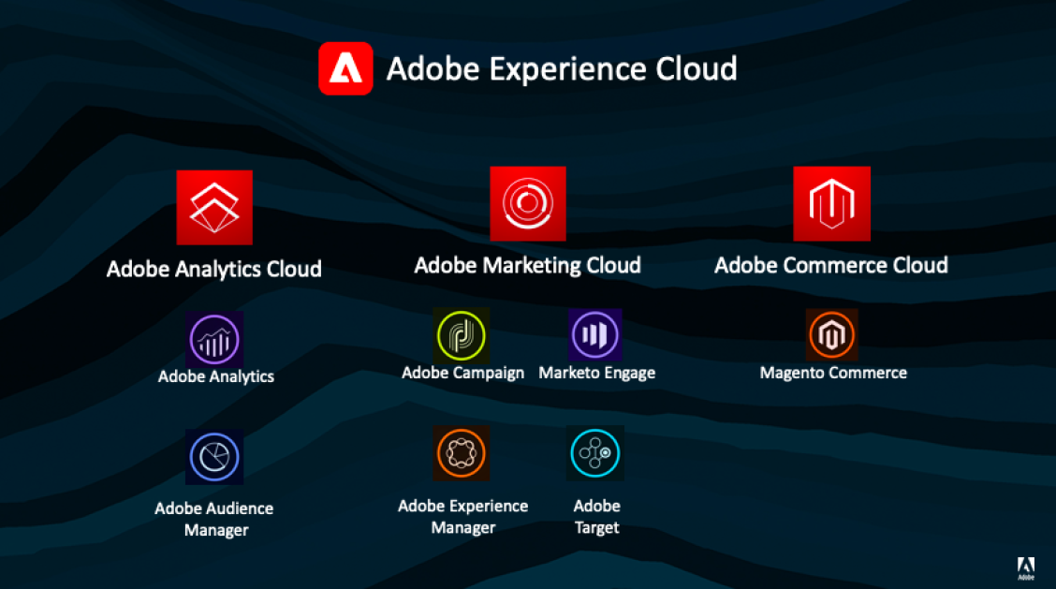

Fig 2.1 Adobe Experience Cloud

Launch is not an update to the existing Tag Management System by Adobe, namely [Adobe DTM](https://www.nabler.com/adobe-dtm-consulting/). Instead, it is an entirely new product with a new codebase. It has been redesigned from scratch using an API-first approach. Everything is built on a robust set of APIs, which makes the system very powerful, flexible, and customizable.

## Adobe Launch Functionalities:

An overview of all the varied functionalities Adobe Launch offers that makes it so unique:

**1)** **Rule Conditions**:

Adobe Launch’s Rule Conditions enables users to apply constraints to event triggers. For instance, it might not be in one’s best interest to load a conversion pixel on every page. The rule needs to be more specific. In such a case, we would need to fulfill a condition that will be a trigger to take the desired action. This functionality reduces the multiplicity of Tag firing and reduces redundancy.

The basic rule structure is:

Events (If): The event is what one wants the rule to look for. This is defined by choosing an event, any applicable conditions, and any exceptions.

Actions (Then): Triggers occur after a rule’s events take place and all conditions are satisfied. A rule in Launch can trigger as many discrete actions as the user wants and can control the order in which these actions occur.

A user can add more event types. Multiple events are joined with an OR, so the rule’s conditions will be evaluated if any of the events are met.

**2)** **Asynchronous Tag Loading**:

In an age where people require the highest value with minimum time investment, websites that take time longer time to load are just committing self-sabotaging.

With multiple tags firing on a web page synchronously, the page load time gets affected adversely and leads to fewer conversions. With Adobe Launch, users get the advantage of firing their tags asynchronously which doesn’t affect the page load time in the slightest.

To do this, we’ll add an async attribute to the script tag by changing:

<script src="//assets.adobedtm.com/launch-EN1a3807879cfd4acdc492427deca6c74e.min.js"></scrip>

to this

<script src="//assets.adobedtm.com/launch-EN1a3807879cfd4acdc492427deca6c74e.min.js" ***async***></script>

Asynchronous Tag firing does come along with a few caveats. For example, the JavaScript on the page is loaded after the content of the page is displayed to the visitor. In platforms where JavaScript code is required to run before the display of the web page’s content, this functionality can alter the website’s appearance and functionality. However, this added functionality is a boon to [those customers](https://instasize.com/blog/5-tools-that-can-help-you-build-your-photography-business) who are facing lag in website load time owing to extensive Tag utilization.

**3)** **Extensions**:

An extension is a packaged set of code that extends the Launch interface and the library functionality. Launch is the platform, and extensions are like apps that run on the platform. Adding an extension adds new data elements and new options for creating rules.

Launch is the only tag management system on the market that allows technology providers to create and update their integrations. Extensions determine the elements that are available when building properties, rules, and data elements. They provide:

* Events, conditions, and exceptions
* Data elements
* Client-side code

Launch is highly extendible. Extensions add core functionality to Launch. A common use of extensions is to create integrations with other applications. Follow the following steps to add a new extension to your Adobe Launch.

* From a property’s overview page, open the Extensions tab.
* Select an extension.
  + If the extension exists, select it from the extensions catalog.
  + Mouse over an extension in your list to configure or disable it.
  + Add other extensions from the catalog if they are not currently on your list.
* The Core extension is the starting point for your new extension. The default extension provides:
  + Default event
  + Default conditions and exceptions
  + Default client-side code

These defaults are the basis for the custom rules you’ll build to create your extension.

**4)** **Multiple Development Environments**:

Launch allows for unlimited development environments, a staging environment, and a production environment. This is great news when you have several developers working in their environments on different parts of your sites or applications.

Following are the steps to create a new environment in Adobe Launch

* Open the Environments tab.
* Click Create a New Environment.
* Select the type of environment you want to create.
  + **Development:** The environment where you create and edit events, configurations, and so on.
  + **Staging:**The environment where you test and approve your changes.
  + **Production:**The environment where your embedded codes are placed in the pages or applications that are available to the public.
* Select your host.
* Click Save.
* In the Web Install Instructions dialog box, select whether to load the library asynchronously. If you choose to load the library asynchronously, copy the embedded code provided in the dialog box. You can also install your embedded code later by clicking the Install icon for that environment in your Environments list. Refer to the information below.
* Repeat for each environment in your development, approval, and publishing change.
* After the environments are created, you are ready to publish.

**5) Centralized rights management:**

Administrators can control who can publish, but they can also control who has access to different parts of Launch. With granular rights management, administrators can designate who has access to specific integrations — and who doesn’t. Users get the liberty to simply create rules that have very specific rights and/or access, then select the individuals who have permission to use those rights or access, creating an approved group. These tools help administrators know who has what access, and allows them to make quick, easy changes to get people the rights they need without spreading rights throughout the organization unnecessarily.

Fig 2.2 Adobe Experience Platform

## Creating Dashboard:

A dashboard is a collection of thumbnail reports called reportlets. A dashboard is most useful when it contains related reportlets that give you complete overviews of certain aspects of your site, such as finding methods, visitor profiles, and so on.

You can add most marketing reports to a dashboard, including graphically intense reports like the Fallout Report, Conversion Funnel Report, and the Pathfinder Report.

You can also set a dashboard as your landing page, share dashboards with other users, and schedule them for delivery. If you do not set a dashboard (or a bookmark) as a landing page, the My Recommended Reports dashboard displays. **My Recommended Reports** shows the **Key Metrics** report plus your five most frequently viewed reports. It is dynamic and based on the actual reports that you view the most.

Fig 2.3 Dashboard Page Loads

The interface of adobe launch used for analytics is shown in above image which contains the page loads which are triggered for a particular project. Then one by one all the variables are tested by breaking down the pages with the variables and check whether the values are correct or not.

Fig 2.4 Dashboard Product hierarchy

The product hierarchy in the above image tells in detail about the products in the project. A single project can contain a single product or multiple products.

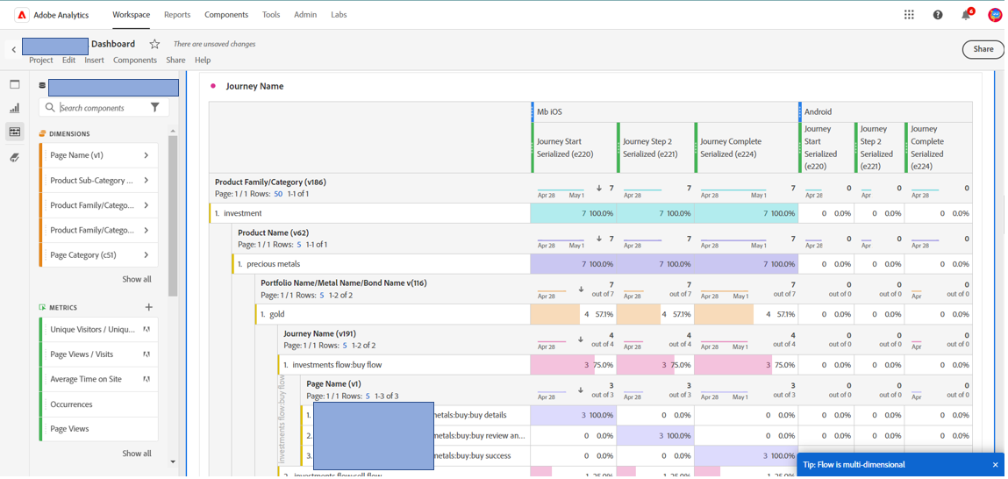

Fig 2.5 Dashboard Journey tracking

The above image shows the journey tracking of any application or funnel which is in the project to identify how many started the journey, how many have completed and how many left in between the process and at which step.

**Website(User Interface):**

1. **Home Page**

Fig 2.6 Home Page

1. **Sign Up Page**

Fig 2.7 Sign Up Page

1. **Project Index Page**

Fig 2.8 Project Index Page

1. **Create New Project Page**

Fig 2.9 Create New Project Page

**Result and Discussion:**

The Adobe Experience allowed to create a dashboard which contained all the dimensions of the webpages for example – page loads, product variables and journey serialized. Over the course of the project, we developed a dashboard that allows analysts to validate whether the pages are being triggered, whether the data is being tracked, and if the data being tracked is correct or not and is meaningful to the organization. We also implemented a customizable journey flow that allows analysts to define the different stages at which a user reached throughout the journey, also – how many have started the journey, how many have completed and how many left in between and at which step.

Overall, the results of AEP demonstrate that the platform is effective in identifying issues and analyzing the data in an efficient way. The customizable journey flow allows analysts to understand where the users might be facing problems, or at which step user left the process.

**Conclusion:**

The AEP is one of the most preferred platforms for analytics, it is easy to use and has a lot of features which makes analysis easy, quick, and efficient. AEP was used in this project to create meaningful and easy to understand dashboards and track issues with websites and apps. Through AEP, which has a lot of features, we were able to learn about Adobe Launch, whose functionalities has been discussed in the report, providing an API- first design, which allows scripting to automate technology deployments, publishing workflows, data collection and sharing and more.

Overall, we were successful in creating a dashboard that provides a comprehensive solution for issue tracking and data analysis. AEP can manage multiple projects with customizable workflows and dashboards, making it an effective tool for data analysis.

**References:**

1. Adobe Experience Platform. (2021) Retrieved from [https://business.adobe.com/in/products/experience-platform/launch.html](https://rubyonrails.org/)
2. Adobe Analytics. (2022). Retrieved from  [https://business.adobe.com/in/products/analytics/adobe-analytics.html](%20https://business.adobe.com/in/products/analytics/adobe-analytics.html%20)
3. Tag Management System. (2021). Retrieved from [https://digitalmarketing.grazitti.com/blog/how-to-implement-configure-adobe-launch/#:~:text=Adobe%20Launch%20is%20the%20next,based%20on%20your%20organization's%20needs.](https://pragprog.com/titles/rails6/agile-web-development-with-rails-6/)
4. Functionalities of Adobe Launch. (2021). Retrieved from https://www.nabler.com/adobe-analytics/articles/5-ways-make-most-out-of-adobe-launch/
5. Dashboard and Reportlets. (2023). Retrieved from [https://experienceleague.adobe.com/docs/analytics/analyze/reports-analytics/dashboard.html?lang=en](https://stackoverflow.com/)